**Supplementary Material for**

**Ecological indicators for coral reef fisheries management**

Authors:

Kirsty L Nash and Nicholas AJ Graham

***File includes:***

Table S1: Publications included in review

Table S2: Summary of gradients used in publications

Table S3: Summary of survey methods used in publications

Table S4: Summary of indicators used in publications

Table S5: Summary of scales of analysis used in publications

Table S6: Methods for estimating indicators

Figure S1: Effects of fishing on community level density indicators across different scales of analysis

Figure S2: Effects of fishing on community level density indicators across different types of fishing gradient

**Table S1.** Summary of publications returned in literature search that were selected for inclusion in the review. See methods section for specific criteria used for selecting publications for inclusion.

|  |  |  |  |  |  |
| --- | --- | --- | --- | --- | --- |
| **#** | **Ref** | **Year** | **Journal** | **Location** | **In-depth review** |
| 1 | Aburto-Oropeza | 2011 | PLOS One | Gulf of California | Y |
| 2 | Alcala & Russ | 1990 | ICES Jr Mar Sci | Philippines | N |
| 3 | Alcala et al. | 2005 | Can Jr Fish Aq Sci | Philippines | N |
| 4 | Amand et al | 2004 | Aq Liv Res | New Caledonia | N |
| 5 | Aswani & Sabetian | 2010 | Cons Biol | Solomon Islands | Y |
| 6 | Aswani et al. | 2007 | Coral Reefs | Solomon Islands | Y |
| 7 | Babcock et al. | 2010 | PNAS | Kenya and Philippines | N |
| 8 | Bartlett et al. | 2009 | Cons Biology | Vanuatu | N |
| 9 | Beets | 1997 | Proc 8th Int Coral Reef Symp | US Virgin Islands | Y |
| 10 | Brewer et al. | 2009 | Biol Cons | Solomon Islands | N |
| 11 | Campbell & Pardede | 2006 | Fish Res | Indonesia | Y |
| 12 | Chiappone et al. | 2000 | MEPS | Caribbean | Y |
| 13 | Clua & Legendre | 2008 | Aq Liv Res | Tonga | Y |
| 14 | Craig et al. | 2008 | Fish Res | American Samoa | N |
| 15 | Currie et al. | 2012 | African Jr Mar Sci | S.Africa & Mozambique | Y |
| 16 | Daw et al. | 2011 | Coast Manag | Western Indian Ocean | N |
| 17 | DeMartini et al. | 2008 | MEPS | Northern Line Islands | Y |
| 18 | Dulvy et al. | 2002 | Jr Expt Mar Biol Ecol | Fiji | Y |
| 19 | Dulvy et al. | 2004 | Can Jr Fish Aq Sci | Fiji | Y |
| 20 | Dulvy et al. | 2004 | Ecol Lett | Fiji | Y |
| 21 | Edwards et al. | 2014 | Proc B | Global | Y |
| 22 | Eklof et al. | 2009 | MEPS | Kenya | Y |
| 23 | Ferraris et al. | 2005 | MEPS | New Caledonia | N |
| 24 | Francini-Filho & Moura | 2008 | Fish Res | Brazil | N |
| 25 | Freed & Granek | 2014 | Coast Manag | Comoros | Y |
| 26 | Friedlander & DeMartini | 2002 | MEPS | Hawaii | Y |
| 27 | Friedlander et al. | 2007 | Ecol App | Hawaii | Y |
| 28 | Friedlander et al. | 2007 | MEPS | Hawaii | Y |
| 29 | Galal et al. | 2002 | Mar & FW Res | Egypt | N |
| 30 | Gascuel et al | 2005 | ICES Jr Mar Sci | New Caledonia | N |
| 31 | Goetze et al. | 2011 | Coral Reefs | Fiji | Y |
| 32 | Graham et al. | 2005 | Coral Reefs | Fiji | Y |
| 33 | Graham et al. | 2007 | Cons Biol | Seychelles | N |
| 34 | Grigg | 1994 | MEPS | Hawaii | Y |
| 35 | Guillemot et al. | 2014 | Ecol Ind | New Caledonia | Y |
| 36 | Harborne et al. | 2008 | Jr App Ecol | Bahamas | Y |
| 37 | Hawkins & Roberts | 2004 | Cons Biol | Caribbean | Y |
| 38 | Hawkins et al. | 2007 | Aq Cons: Mar & FW Ecosys | Caribbean | Y |
| 39 | Huntington et al. | 2010 | PLOS One | Belize | Y |
| 40 | Januchowski-Hartley et al. | 2011 | PLOS One | PNG | Y |
| 41 | Jennings & Polunin | 1996 | Jr App Ecol | Fiji | Y |
| 42 | Jennings & Polunin | 1997 | Coral Reefs | Fiji | Y |
| 43 | Jennings et al. | 1995 | Coral Reefs | Seychelles | Y |
| 44 | Jennings et al. | 1996 | Biol Cons | Seychelles | Y |
| 45 | Karnauskas & Babcock | 2014 | Ecol Indic | Belize | Y |
| 46 | Karnauskas et al. | 2011 | Fish Res | Navassa | Y |
| 47 | Karnauskas et al. | 2011 | MEPS | Belize | N |
| 48 | Karr et al. | 2015 | Jr App Ecol | Caribbean | Y |
| 49 | Klomp et al. | 2001 | Proc Gulf Caribb Fish Instit | Caribbean | N |
| 50 | KrOnen et al. | 2012 | Ocean Coast Manag | Pacific Islands | Y |
| 51 | Letourneur et al. | 2000 | Aq Liv Res | New Caledonia | N |
| 52 | Lindfield | 2014 | PLOS One | Guam | Y |
| 53 | Mateos-Molina et al. | 2014 | Fish Res | Puerto Rico | N |
| 54 | McClanahan | 1994 | Coral Reefs | Kenya | Y |
| 55 | McClanahan | 2008 | Oecologia | Kenya | N |
| 56 | McClanahan | 2014 | MEPS | Kenya | N |
| 57 | McClanahan & Arthur | 2001 | Ecol App | Kenya & Tanzania | N |
| 58 | McClanahan & Graham | 2005 | MEPS | Kenya | N |
| 59 | McClanahan & Humphries | 2012 | MEPS | Kenya | Y |
| 60 | McClanahan &Kaunda-Arara | 1996 | Cons Biol | Kenya | Y |
| 61 | McClanahan et al. | 1997 | Environ Cons | Kenya | N |
| 62 | McClanahan et al. | 1999 | Biol Cons | Kenya & Tanzania | Y |
| 63 | McClanahan et al. | 2001 | Coral Reefs | Belize | Y |
| 64 | McClanahan et al. | 2007 | Ecol App | Kenya | N |
| 65 | McClanahan et al. | 2009 | MEPS | Western Indian Ocean | N |
| 66 | McClanahan et al. | 2011 | MEPS | Belize | N |
| 67 | McClanahan et al. | 2011 | PNAS | Indian Ocean | Y |
| 68 | McClanahan et al. | 2015 | Cons Biol | Indian Ocean | Y |
| 69 | Micheli et al. | 2014 | Biol Cons | Bahamas | Y |
| 70 | Miller & Gerstner | 2002 | Biol Cons | Navassa | N |
| 71 | Mora | 2008 | Proc B | Caribbean | Y |
| 72 | Ohman et al. | 1997 | Env Biol Fish | Sri Lanka | N |
| 73 | O'Leary et al. | 2013 | MEPS | Kenya | N |
| 74 | Pet-Soede et al. | 2001 | Fish Res | Sulawesi | Y |
| 75 | Pinca et al. | 2012 | Fish Fisheries | Pacific Islands | Y |
| 76 | Polunin & Roberts | 1993 | MEPS | Saba & Belize | Y |
| 77 | Preuss et al. | 2009 | ICES Jr Mar Sci | New Caledonia | N |
| 78 | Roberts | 1995 | Cons Biol | Saba | Y |
| 79 | Roberts et al. | 2001 | Science | St. Lucia | N |
| 80 | Russ & Alcala | 1989 | MEPS | Philippines | N |
| 81 | Russ & Alcala | 1996 | Ecol App | Philippines | N |
| 82 | Russ & Alcala | 2003 | Ecol App | Philippines | N |
| 83 | Russ & Alcala | 1998a | Coral Reefs | Philippines | N |
| 84 | Russ & Alcala | 1998b | Coral Reefs | Philippines | N |
| 85 | Russ et al. | 2004 | Ecol App | Philippines | Y |
| 86 | Sandin et al. | 2008 | PLOS One | Northern Line Islands | Y |
| 87 | Smith et al. | 2011 | Fish Res | Caribbean | N |
| 88 | Stallings | 2009 | PLOS One | Caribbean | Y |
| 89 | Stamoulis & Friedlander | 2013 | Fish Res | Hawaii | N |
| 90 | Tilot et al. | 2008 | Aq Cons: Mar & FW Ecosys | Red Sea | Y |
| 91 | Tittensor et al. | 2007 | Ecol Lett | Pacific & Indian Ocean | Y |
| 92 | Tyler et al. | 2009 | Biol Cons | Tanzania | Y |
| 93 | Tyler et al. | 2011 | Aq Cons: Mar & FW Ecosys | Tanzania | Y |
| 94 | Valles & Oxenford | 1994 | PLOS One | Caribbean | Y |
| 95 | Walmsley & White | 2003 | Env Cons | Philippines | Y |
| 96 | Walsh et al. | 2012 | Jr Fish Biol | Northern Line Islands | N |
| 97 | Wantiez et al. | 1997 | Coral Reefs | New Caledonia | Y |
| 98 | Watson & Ormond | 1994 | MEPS | Kenya | Y |
| 99 | Westera et al. | 2003 | Jr Expt Mar Biol Ecol | Ningaloo | Y |
| 100 | Williams & Polunin | 2000 | Env Cons | Caribbean | N |
| 101 | Williams et al. | 2006 | MEPS | Hawaii | N |
| 102 | Williams et al. | 2008 | Env Cons | Hawaii | Y |
| 103 | Wilson et al. | 2008 | Global Change Biol | Fiji | N |
| 104 | Wilson et al. | 2010 | Ecol App | Fiji | Y |
| 105 | Wilson et al. | 2012 | Mar Env Res | Ningaloo | Y |

**Table S2.** Summary of gradients used in publications incorporated into initial review (n=105).

|  |  |
| --- | --- |
| **Gradient** | **Number of publications** |
| Spatial | 72 |
| Temporal | 8 |
| Both | 25 |

**Table S3.** Summary of survey techniques used in publications incorporated into initial review (n=105).

|  |  |
| --- | --- |
| **Type of Fishery-Independent Survey** | **Number of publications** |
| Underwater data collection | 102 |
| Fishery-independent catch data | 3 |

**Table S4.** Summary of indicators used in publications incorporated into initial review (n=105).

|  |  |
| --- | --- |
| **Indicator Type** | **Number of publications** |
| **Density-based indicators** |  |
| Biomass | 68 |
| Abundance | 63 |
| Abundance variability | 1 |
| Biomass variability | 1 |
| **Size-based indicators** |  |
| Size distribution | 17 |
| Mean size | 13 |
| Size spectra intercept | 9 |
| Size spectra slope | 8 |
| Mean max size | 5 |
| Size at maturity | 1 |
| Size composition | 1 |
| Size distribution (Lmax) | 1 |
| Size to achieve optimum yield | 1 |
| **Life history-based indicators** |  |
| Growth rate | 3 |
| Age at maturity | 2 |
| Generation time | 2 |
| Lifespan | 2 |
| Natural mortality | 2 |
| Sex ratio | 1 |
| **Function-based indicators** |  |
| Proportion of functional group | 7 |
| Composition of functional groups | 6 |
| Mean trophic level | 4 |
| Grazing rate | 3 |
| Functional redundancy | 1 |
| Functional richness | 1 |
| **Community-based indicators** |  |
| Richness | 41 |
| Community composition | 28 |
| Diversity | 7 |
| Proportion of target individuals | 1 |
| **Behavioural indicators** |  |
| Flight initiation distance | 1 |
| **Ecosystem indicators** |  |
| Coral | 33 |
| Algae | 25 |
| Urchins | 13 |
| Structural complexity | 11 |
| Benthos | 7 |
| Mobile invertebrates (other than urchins) | 3 |

**Table S5.** Summary of the scale of analyses used in publications in in-depth review (n=65). We assigned studies to these scale categories based on the spatial extent of the study

|  |  |
| --- | --- |
| **Scale** | **Number of publications** |
| Local | 42 |
| Regional | 21 |
| Local and regional | 1 |
| Regional and global | 1 |

**Table S6.** Methods for estimating A) Density, B) Community, C) Size, D) Life-history, E) Function and F) Ecosystem indicators.

|  |  |  |
| --- | --- | --- |
| **Indicator Estimation** | | **Key References** |
| **A) Density-based indicators** |  | |
| **Density $$Density=\frac{\sum{N}}{A}$$**  N is abundance or biomass; A is survey area | Other ecosystems   * Rochet and Trenkel (2003)   Coral reefs   * Jennings et al. (1995) * Karnauskas and Babcock (2014) | |
| **Density variability $$CV= \frac{sd(Density)}{mean(Density)}$$**  CV is coefficient of variation; sd is standard deviation | Other ecosystems   * Shin et al. (2010) * Shannon et al. (2010)   Coral reefs   * Freed and Granek (2014) | |
| **B) Size-based indicators** |  | |
| **Density or proportion large fish $$Density=\frac{N>Ref size}{A}$$ $$Proportion=\frac{N>Ref Size}{\sum{N}}$$**  N > Ref Size is abundance or biomass of individuals larger than reference size; A is survey area | Other ecosystems   * Shin et al. (2005) * Greenstreet et al. (2011)   Coral reefs   * Guillemot et al. (2014) | |
| **Mean size $$Mean size=\frac{\sum{L}}{N}$$**  L is length or weight of individuals; N is abundance or biomass | Other ecosystems   * Link et al. (2002) * Trenkel and Rochet (2003)   Coral reefs   * Dulvy et al. (2004) * Clua and Legendre (2008) | |
| **Mean maximum size $$Mean\max{size}=\frac{\sum{({Lmax}_{i}*N_{i}})}{\sum{N}}$$**  Lmaxi is maximum length or weight of species i;  Ni is abundance or biomass of species i | Other ecosystems   * Fulton et al. (2005) * Link (2005)   Coral reefs   * Dulvy et al. (2004) * Babcock et al. (2013) | |
| **Mean length at maturity $$Mean size at maturity=\frac{\sum{{Lmat}_{i}*N_{i}}}{\sum{N}}$$**  Lmati is mean length at maturity of species i ;  Ni is abundance or biomass of species i | Other ecosystems   * Jennings et al. (1999) * Greenstreet and Rogers (2006)   Coral reef   * McClanahan and Humphries (2012) * Taylor et al. (2014) | |
| **Mean length at sex change $$Mean length at sex change=\frac{\sum{{L∆}_{i}*N_{i}}}{\sum{N}}$$**  L∆i is mean length at sex change of species i;  Ni is abundance or biomass of species i | Coral reefs   * Taylor (2014) | |
| **Size spectra – slope and midpoint $$Slope of plot: Log\left(N\right)\sim Log(L)$$ $$Midpoint (intercept) of plot: Log\left(N\right)\sim Log(L)$$**  L is length or weight of individuals; N is abundance or biomass; Normalise data by dividing density in size class by width of class | Other ecosystems:   * Gislason and Rice (1998)   Coral reefs:   * Dulvy et al. (2004) * Graham et al. (2005) | |
| **Size distribution**  Frequency distribution of biomass or abundance of different length or weight classes | Other ecosystems   * Trenkel and Rochet (2003) * Blanchard et al. (2005)   Coral reefs   * Polunin and Roberts (1993) | |
| **Ratio: Mean length to Mean length at maturity $$\frac{Mean length}{Mean length at maturity}$$** | Other ecosystems   * Froese (2004)   Coral reefs:   * Babcock et al. (2013) | |
| **C) Life history-based indicators** |  | |
| **Mean age at maturity $$Meanage at maturity=\frac{\sum{({tm}_{i}*N_{i}})}{\sum{N}}$$**  tmi is mean age at maturity of species i;  Ni is abundance or biomass of species i | Other ecosystems   * Rochet and Trenkel (2003) * Greenstreet and Rogers (2006)   Coral reefs   * Taylor et al. (2014) * McClanahan et al. (2015) | |
| **Mean lifespan $$Mean lifespan= \frac{\sum{({tmax}_{i}*N_{i})}}{\sum{N}}$$**  tmaxi is maximum age of species i;  Ni is abundance or biomass of species i | Other ecosystems   * Shin et al. (2010) * Henriques et al. (2014)   Coral reefs   * Taylor et al. (2014) * McClanahan et al. (2015) | |
| **Growth rate $$Mean growth rate= \frac{\sum{\left(k_{i}*N_{i}\right)}}{\sum{N}}$$**  k is von Bertalanffy growth parameter for species i;  Ni is abundance or biomass of species i | Other ecosystems   * Jennings et al. (1999) * Greenstreet and Rogers (2006)   Coral reefs   * McClanahan and Humphries (2012) * McClanahan et al. (2015) | |
| **Generation time $$Meangeneration time= \frac{\sum{\left(G_{i}*N_{i}\right)}}{\sum{N}}$$**  G is generation time of species i; Ni is abundance or biomass of species i | Coral reefs   * McClanahan and Humphries (2012) * McClanahan et al. (2015) | |
| **D) Community composition indicators** |  | |
| **Community composition**  Species densities may be compared among sites using distances matrices e.g. Bray-Curtis dissimilarity and may be visualized using non-metric multidimensional scaling (nMDS). Differences may be assessed using Analysis of Similarities (ANOSIM) | Other ecosystems   * Rochet and Trenkel (2003)   Coral reefs   * Clua and Legendre (2008) * Vallès and Oxenford (2014) | |
| **Diversity $$Hill's N_{1}=e^{(-\sum{p_{i}ln{(p}_{i})})}$$**  Or $Hill's N_{2}=\frac{1}{\sum{p_{i}^{2}}}$ pi is the proportion abundance of species i;  Hill’s N1 emphasises richness whereas Hill’s N2 emphasises evenness | Other ecosystems   * Gislason and Rice (1998) * Greenstreet and Rogers (2006)   Coral reefs   * Jennings et al. (1995) * Babcock et al. (2013) | |
| **W-statistic for Abundance-Biomass Curves $$W=\frac{\sum{(B_{i}-A_{i})}}{50*(S-1)}$$**  Bi is the biomass of species rank i; Ni is the abundance of species rank i; S is the number of species | Other ecosystems   * Warwick (1986) * Yemane et al. (2005) | |
| **E) Functional indicators** |  | |
| **Functional richness $$Functional richness=FG$$**  FG is number of functional groups | Coral reefs   * Micheli et al. (2014) | |
| **Functional diversity**  Range of different indicators based on distribution of biomass or abundance within trait space. Examples include functional identity; functional evenness; functional divergence; functional dispersion | Other ecosystems   * Villéger et al. (2008) * Laliberté and Legendre (2010)   Coral reefs   * Mouillot et al. (2012) | |
| **Density or proportion of functional group $$Density=\frac{N_{FG}}{A}$$ $$Proportion=\frac{N_{FG}}{\sum{N}}$$**  NFG is abundance or biomass of functional group; A is survey area | Other ecosystems:   * Henriques et al. (2014)   Coral reefs:   * Sandin et al. (2008) * McClanahan et al. (2011) | |
| **F) Ecosystem indicators** |  | |
| **Benthic community composition**  Percentage cover of benthic taxa may be compared among sites using distances matrices e.g. Euclidean distances and may be visualized using principle component analysis (PCA). Differences may be assessed using Analysis of Similarities (ANOSIM) | Coral reefs   * Westera et al. (2003) * Friedlander et al. (2007) | |
| **Crustose coralline algae cover $$CCA cover=\frac{CCA}{A}$$**  CCA is area covered by crustose coralline algae; A is survey area | Coral reefs   * McClanahan and Arthur (2001) * Dulvy et al. (2002) | |
| **Hard coral cover $$Coral cover=\frac{HC}{A}$$**  HC is area covered by hard coral; A is survey area | Coral reefs   * Grigg (1994) * Roberts (1995) | |
| **Macroalgal cover $$CCA cover=\frac{CCA}{A}$$**  MA is area covered by macroalgae; A is survey area | Coral reefs   * McClanahan and Arthur (2001) * Dulvy et al. (2002) | |
| **Ratio: Coral to Macroalgal cover $$Coral:Macroalgal ratio=\frac{HC}{MA}$$**  HC is area covered by hard coral; MA is area covered by macroalgae | Coral reefs   * Huntington et al. (2010) * McClanahan et al. (2011) | |
| **Structural complexity $$Six point visual scale$$**  Or $Rugosity index=\frac{LD}{SD}$ LD is distance covered when a chain or tape is pulled taught across the benthos; SD is the linear distance between the start and end of the chain or tape when it is draped over the contours of the benthos | Coral reefs   * Roberts (1995) * Dulvy et al. (2002) | |
| **Urchin density $$Density=\frac{N}{A}$$**  N is biomass or abundance of urchins; A is survey area | Coral reefs   * Watson and Ormond (1994) * McClanahan et al. (1999) | |
| **Urchin predation index $$Predation Index=\frac{U}{T}$$**  U is the survival rate of urchins; T is the time over which the survival of urchins is estimated | Coral reefs   * McClanahan et al. (1999) * McClanahan et al. (2011) | |

**Figure S1.** Number of publications reporting the effect of fishing on indicators estimated at the community level, for studies looking at either A) local or B) regional scales. X-axis represents change in indicator value in response to an increase in fishing pressure, either along a fishing gradient or from no-take to fished areas. Only those indicators presented more than 5 times in the literature are shown.

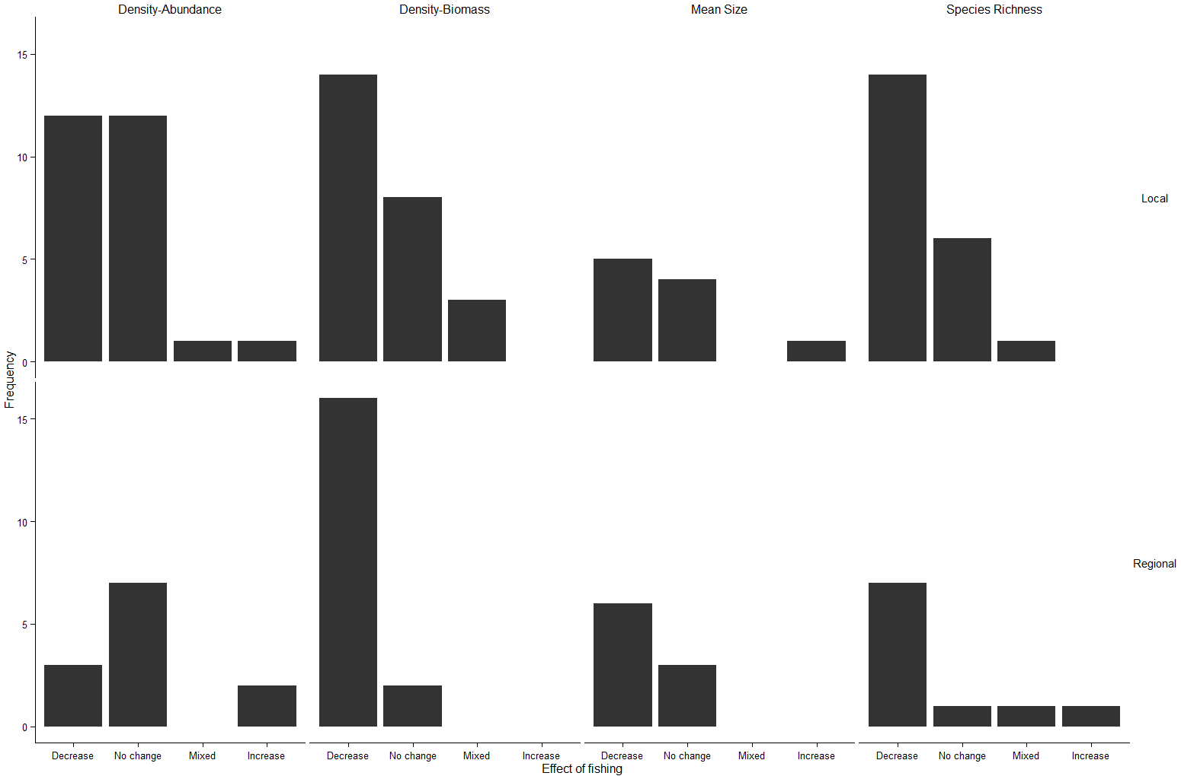

**B**

**A**

**Figure S2.** Number of publications reporting the effect of fishing on indicators estimated at the community level, for a range of fishing gradients: A) MPA versus fished; B) MPA versus a fishing gradient; C) a fishing gradient; and D) a gradient in fishing over time. X-axis represents change in indicator value in response to an increase in fishing pressure. Only those indicators presented more than 5 times within different fishing gradients in the literature are shown.

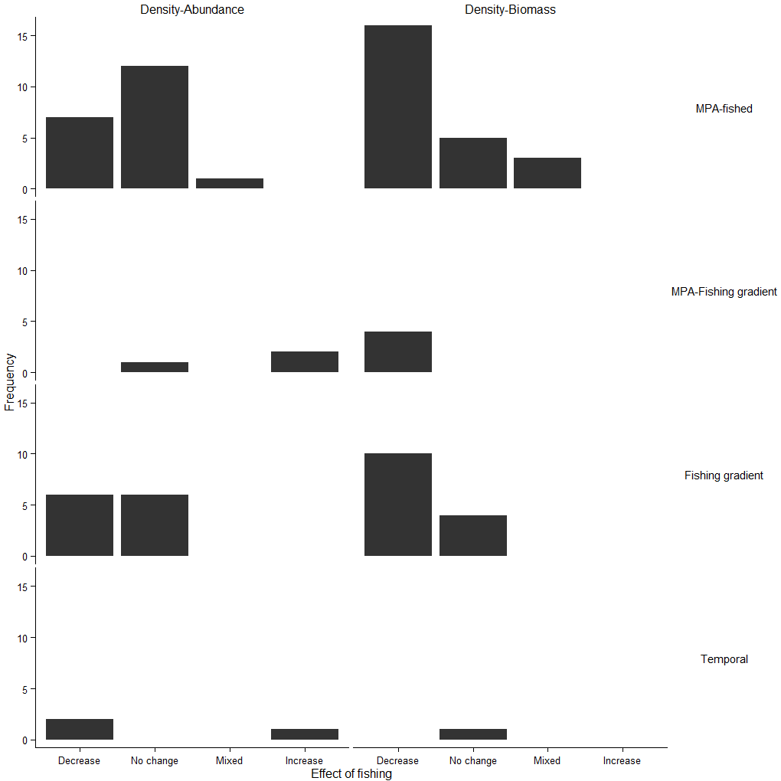

**D**

**C**

**B**

**A**

**References**

Babcock, E.A., Coleman, R., Karnauskas, M., Gibson, J. (2013) Length-based indicators of fishery and ecosystem status: Glover's Reef Marine Reserve, Belize. *Fisheries Research* **147,** 434-445.

Blanchard, J.L., Dulvy, N.K., Jennings, S.*, et al.* (2005) Do climate and fishing influence size-based indicators of Celtic Sea fish community structure? *ICES Journal of Marine Science* **62,** 405-411.

Clua, E., Legendre, P. (2008) Shifting dominance among Scarid species on reefs representing a gradient of fishing pressure. *Aquatic Living Resources* **21,** 339-348.

Dulvy, N.K., Mitchell, R.E., Watson, D., Sweeting, C.J., Polunin, N.V.C. (2002) Scale-dependant control of motile epifaunal community structure along a coral reef fishing gradient. *Journal of Experimental Marine Biology and Ecology* **278,** 1-29.

Dulvy, N.K., Polunin, N.V.C., Mill, A.C., Graham, N.A.J. (2004) Size structural change in lightly exploited coral reef fish communities: evidence for weak indirect effects. *Canadian Journal of Fisheries and Aquatic Sciences* **61,** 466-475.

Freed, S., Granek, E.F. (2014) Effects of human activities on the world's most vulnerable coral reefs: Comoros case study. *Coastal Management* **42,** 280-296.

Friedlander, A.M., Brown, E.K., Monaco, M.E. (2007) Coupling ecology and GIS to evaluate efficacy of marine protected areas in Hawaii. *Ecological Applications* **17,** 715-730.

Froese, R. (2004) Keep it simple: three indicators to deal with overfishing. *Fish and Fisheries* **5,** 86-91.

Fulton, E.A., Smith, A.D.M., Punt, A.E. (2005) Which ecological indicators can robustly detect effects of fishing? *ICES Journal of Marine Science* **62,** 540-551.

Gislason, H., Rice, J. (1998) Modelling the response of size and diversity spectra of fish assemblages to changes in exploitation. *ICES Journal of Marine Science* **55,** 362-370.

Graham, N.A.J., Dulvy, N.K., Jennings, S., Polunin, N.V.C. (2005) Size-spectra as indicators of the effects of fishing on coral reef fish assemblages. *Coral Reefs* **24,** 118-124.

Greenstreet, S.P.R., Rogers, S.I. (2006) Indicators of the health of the North Sea fish community: identifying reference levels for an ecosystem approach to management. *ICES Journal of Marine Science* **63,** 573-593.

Greenstreet, S.P.R., Rogers, S.I., Rice, J.C.*, et al.* (2011) Development of the EcoQO for the North Sea fish community. *ICES Journal of Marine Science* **68,** 1-11.

Grigg, R.W. (1994) Effects of sewage discharge, fishing pressure and habitat complexity on coral ecosystems and reef fishes in Hawaii. *Marine Ecology-Progress Series* **103,** 25-34.

Guillemot, N., Chabanet, P., Kulbicki, M.*, et al.* (2014) Effects of fishing on fish assemblages in a coral reef ecosystem: from functional response to potential indicators. *Ecological Indicators* **43,** 227-235.

Henriques, S., Pais, M.P., Vasconcelos, R.P.*, et al.* (2014) Structural and functional trends indicate fishing pressure on marine fish assemblages. *Journal of Applied Ecology* **51,** 623-631.

Huntington, B.E., Karnauskas, M., Babcock, E.A., Lirman, D. (2010) Untangling natural seascape variation from marine reserve effects using a landscape approach. *PLoS ONE* **5,** e12327.

Jennings, S., Grandcourt, E.M., Polunin, N.V.C. (1995) The effects of fishing on the diversity, biomass and trophic structure of Seychelles' reef fish communities. *Coral Reefs* **14,** 225-235.

Jennings, S., Greenstreet, S.P.R., Reynolds, J.D. (1999) Structural change in an exploited fish community: a consequence of differential fishing effects on species with contrasting life histories. *Journal of Animal Ecology* **68,** 617-627.

Karnauskas, M., Babcock, E.A. (2014) An analysis of indicators for the detection of effects of marine reserve protection on fish communities. *Ecological Indicators* **46,** 454-465.

Laliberté, E., Legendre, P. (2010) A distance-based framework for measuring functional diversity from multiple traits. *Ecology* **91,** 299-305.

Link, J.S. (2005) Translating ecosystem indicators into decision criteria. *ICES Journal of Marine Science* **62,** 569-576.

Link, J.S., Brodziak, J.K.T., Edwards, S.F.*, et al.* (2002) Marine ecosystem assessment in a fisheries management context. *Canadian Journal of Fisheries and Aquatic Sciences* **59,** 1429-1440.

McClanahan, T.R., Arthur, R. (2001) The effect of marine reserves and habitat on populations of east African coral reef fishes. *Ecological Applications* **11,** 559-569.

McClanahan, T.R., Graham, N.A.J., MacNeil, M.A., Cinner, J.E. (2015) Biomass-based targets and the management of multispecies coral reef fisheries. *Conservation Biology* **29,** 409-417.

McClanahan, T.R., Graham, N.A.J., MacNeil, M.A.*, et al.* (2011) Critical thresholds and tangible targets for ecosystem-based management of coral reef fisheries. *Proceedings of the National Academy of Sciences of the United States of America* **108,** 17230-17233.

McClanahan, T.R., Humphries, A.T. (2012) Differential and slow life-history responses of fishes to coral reef closures. *Marine Ecology Progress Series* **469,** 121-131.

McClanahan, T.R., Muthiga, N., Kamukuru, A.T., Machano, H., Kiambo, R.W. (1999) The effects of marine parks and fishing on coral reefs of northern Tanzania. *Biological Conservation* **89,** 161-182.

Micheli, F., Mumby, P.J., Brumbaugh, D.R.*, et al.* (2014) High vulnerability of ecosystem function and services to diversity loss in Caribbean coral reefs. *Biological Conservation* **171,** 186-194.

Mouillot, D., Graham, N.A.J., Villéger, S., Mason, N.W.H., Bellwood, D.R. (2012) A functional approach reveals community responses to disturbances. *Trends in Ecology & Evolution* **28,** 167-177.

Polunin, N.V.C., Roberts, C.M. (1993) Greater biomass and value of target coral-reef fishes in two small Caribbean marine reserves. *Marine Ecology Progress Series* **100,** 167-176.

Roberts, C.M. (1995) Rapid buildup of fish biomass in a Caribbean marine reserve. *Conservation Biology* **9,** 815-826.

Rochet, M.J., Trenkel, V.M. (2003) Which community indicators can measure the impact of fishing? A review and proposals. *Canadian Journal of Fisheries and Aquatic Sciences* **60,** 86-99.

Sandin, S.A., Smith, J.E., DeMartini, E.E.*, et al.* (2008) Baselines and degradation of coral reefs in the Northern Line Islands. *PLoS ONE* **3,** e1548.

Shannon, L.J., Coll, M., Yemane, D.*, et al.* (2010) Comparing data-based indicators across upwelling and comparable systems for communicating ecosystem states and trends. *ICES Journal of Marine Science* **67,** 807-832.

Shin, Y.-J., Rochet, M.-J., Jennings, S., Field, J.G., Gislason, H. (2005) Using size-based indicators to evaluate the ecosystem effects of fishing. *ICES Journal of Marine Science* **62,** 384-396.

Shin, Y.-J., Shannon, L.J., Bundy, A.*, et al.* (2010) Using indicators for evaluating, comparing, and communicating the ecological status of exploited marine ecosystems. 2. Setting the scene. *ICES Journal of Marine Science* **67,** 692-716.

Taylor, B.M. (2014) Drivers of protogynous sex change differ across spatial scales. *Proceedings of the Royal Society B: Biological Sciences* **281,** 20132423.

Taylor, B.M., Houk, P., Russ, G., Choat, J.H. (2014) Life histories predict vulnerability to overexploitation in parrotfishes. *Coral Reefs* **33,** 869-878.

Trenkel, V.M., Rochet, M.J. (2003) Performance of indicators derived from abundance estimates for detecting the impact of fishing on a fish community. *Canadian Journal of Fisheries and Aquatic Sciences* **60,** 67-85.

Vallès, H., Oxenford, H.A. (2014) Parrotfish size: a simple yet useful alternative indicator of fishing effects on Caribbean reefs? *PLoS ONE* **9,** e86291.

Villéger, S., Mason, N.W.H., Mouillot, D. (2008) New multidimensional functional diversity indices for a multifaceted framework in functional ecology. *Ecology* **89,** 2290-2301.

Warwick, R.M. (1986) A new method for detecting pollution effects on marine macrobenthic communities. *Marine Biology* **92,** 557-562.

Watson, M., Ormond, R.F.G. (1994) Effect of an artisanal fishery on the fish and urchin populations of a Kenyan coral-reef. *Marine Ecology Progress Series* **109,** 115-129.

Westera, M., Lavery, P., Hyndes, G. (2003) Differences in recreationally targeted fishes between protected and fished areas of a coral reef marine park. *Journal of Experimental Marine Biology and Ecology* **294,** 145-168.

Yemane, D., Field, J.G., Leslie, R.W. (2005) Exploring the effects of fishing on fish assemblages using Abundance Biomass Comparison (ABC) curves. *ICES Journal of Marine Science* **62,** 374-379.